PLUMBER
Images of plumbing pipes and plumber
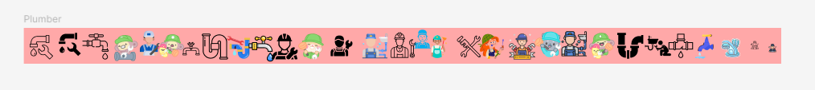
Good service

Whatsapp

Quotation marks
